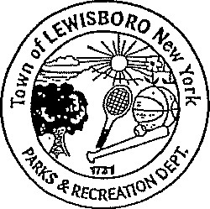
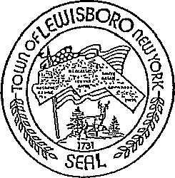
Town of Lewisboro
Parks & Recreation Department
Dana M. Mayclim | Reed Pullem
Superintendent | Recreation Assistant
Laura A. Stone | Pamela Veith
Senior Office Assistant | Senior Adult Coordinator

Michael L. Portnoy
Recreation Assistant

PERMISSION TO CARRY/USE SUNSCREEN AND INSECT REPELLANT

I give permission for my child to carry FDA approved sunscreen, insect repellant and hand sanitizer for over the counter use, and for the camp staff to assist m child at their request in the application of approved sunscreen, insect repellant and hand sanitizer without physical contact of the child. The camp directors will maintain a record of such.

Name: ____________________________ DATE: ____________

Parent/Guardian Signature: ________________________________ DATE: ______________

99 Elmwood Road + South Salem, NY 10590 + (914) 232-6162 + Fax (914) 232-6165 + parks@lewisborogov.com + TTY (800) 662-1220
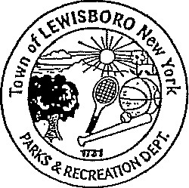
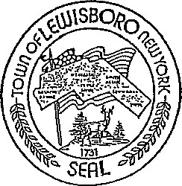
Town of Lewisboro
Parks & Recreation Department
Dana M. Mayclim | Reed Pullem
Superintendent | Recreation Assistant
Laura A. Stone | Pamela Veith
Senior Office Assistant | Senior Adult Coordinator

Michael L. Portnoy
LEWISBORO PARKS AND RECREATION DEPARTMENT
2021

CAMPER OFF-SITE PERMISSION SLIP
Following the New York State Department Health Camp Code Regulations, we must have a permission slip for every camper that attends the Main Event camp program provided by the Lewisboro Parks and Recreation Department. Please fill out the following information and sign below.
My signature below gives permission for my child, to participate in all camp activities at the town park pool. I understand that campers will accompany the Lewisboro Parks and Recreation Department and its camp staff on all trips to the pool.
Date: ___________________ Parents Signature: _______________________
0 Little Explorers
0 Main Event
0 Trailblazing Teens

99 Elmwood Road + South Salem, NY 10590 + (914) 232-6162 + Fax (914) 232-6165 + parks@lewisborogov.com + TTY (800) 662-1220

